DAY 10 — LAB 10

Image Generation: Five-Part Prompt and Iterative Refinement

Here is a completed, submission-ready version of Day 10 – Lab 10. You can replace the observations with your actual tool results if your generated images differ.
DAY 10 — LAB 10
Image Generation: Five-Part Prompt and Iterative Refinement
Step 3 — Diagnose the Weak Prompt
Prompt used:
“Create an airport image.”
Prompt Component | Present or Missing? | What Should Be Added?
Subject | Missing | Specify passengers, kiosks, aircraft, staff, etc.
Style | Missing | Specify photorealistic, corporate photography, illustration, etc.
Environment | Partially present | Specify a modern international airport terminal or check-in area.
Lighting | Missing | Specify natural daylight, professional lighting, etc.
Aspect ratio | Missing | Specify 16:9 for a presentation.
Intended use | Missing | State that the image is for a business presentation.
Brand restrictions | Missing | Exclude airline logos, airport names and trademarks.
Text restrictions | Missing | Exclude readable promotional text and personal information.
Accuracy instructions | Missing | Request realistic airport equipment, passenger movement and aviation details.
Observation
The weak prompt provides very little direction to the image-generation model. As a result, the generated image may vary significantly in subject, composition, airport design, lighting and realism.

Step 4 — Five-Part Image Prompt
Image-Prompt Component | Student Response
Subject | Diverse young adult travellers using self-service check-in kiosks
Medium or style | Professional photorealistic corporate photography
Environment | Modern international airport terminal with realistic travel bags and passenger movement
Lighting | Bright natural daylight with clean professional illumination
Aspect ratio | 16:9 landscape for a business presentation
Final Structured Prompt
Create a professional, photorealistic image of a diverse group of young adult travellers using self-service check-in kiosks inside a modern international airport terminal. Show a clean, spacious environment with realistic travel bags and clear passenger movement. Use bright natural daylight and a neutral blue-and-white colour palette. Use a 16:9 landscape aspect ratio suitable for a business presentation. Do not include airline logos, airport names, readable personal information, boarding-pass details or promotional text.
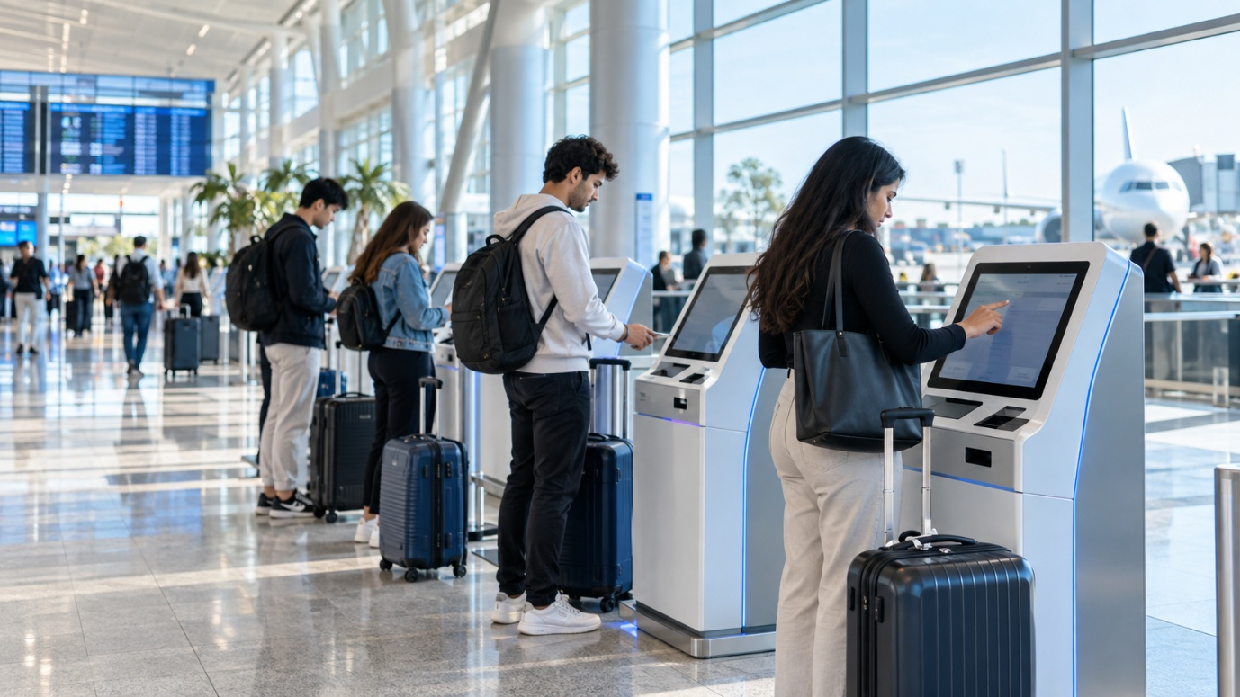

Step 5 — Compare the Weak and Structured Results
Evaluation Criterion | Weak Prompt Image | Structured Prompt Image
Clear subject | Partially clear | Clearly shows young travellers using kiosks
Appropriate aviation setting | General airport setting | Clearly specified modern international terminal
Professional style | Not specified; may vary | Photorealistic and professional
Suitable lighting | Not specified | Bright natural/professional lighting
Correct aspect ratio | Not specified | 16:9 landscape
Realistic details | May contain unrealistic details | More controlled and realistic aviation environment
Unwanted logos or text | May appear | Explicitly restricted
Suitable for presentation use | Limited | More suitable for a business presentation
Conclusion
The structured prompt produced a more useful image because it clearly defined the subject, visual style, environment, lighting and aspect ratio. The environment and subject specifications made the biggest difference because they gave the image-generation tool a clear aviation scenario instead of simply asking for an airport image. The weak prompt could produce unwanted elements such as random signage, unrealistic airport equipment, logos or distorted text. Even if the structured image looks professional, it should still be reviewed before publication because AI-generated images can contain inaccurate details, distorted people, incorrect technology or unreadable text. Therefore, the structured image is suitable as a presentation draft, but human review is still required before publishing or using it for an official aviation communication.

Version -1
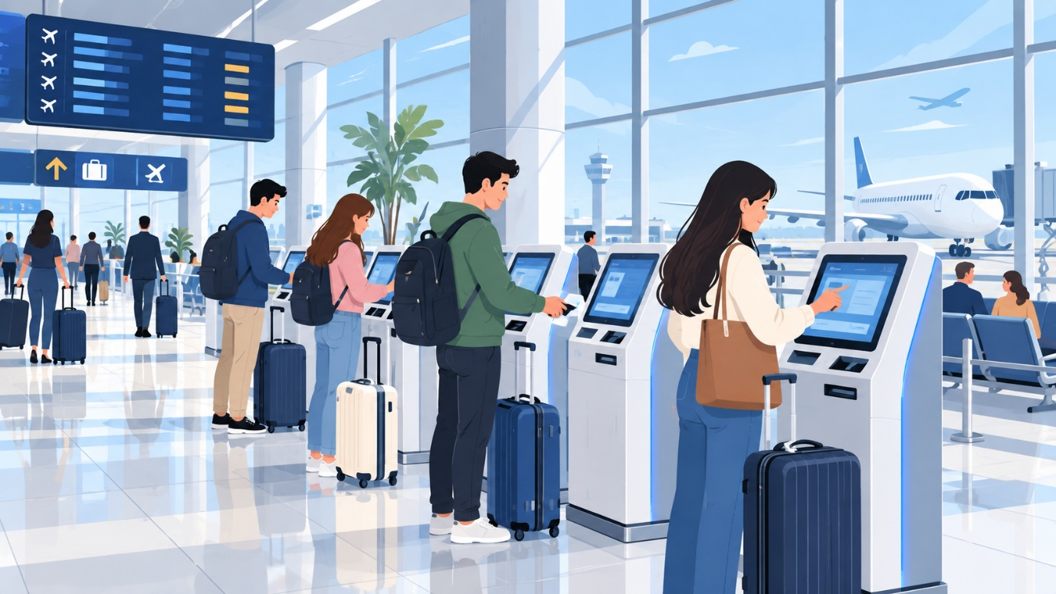

Version -2

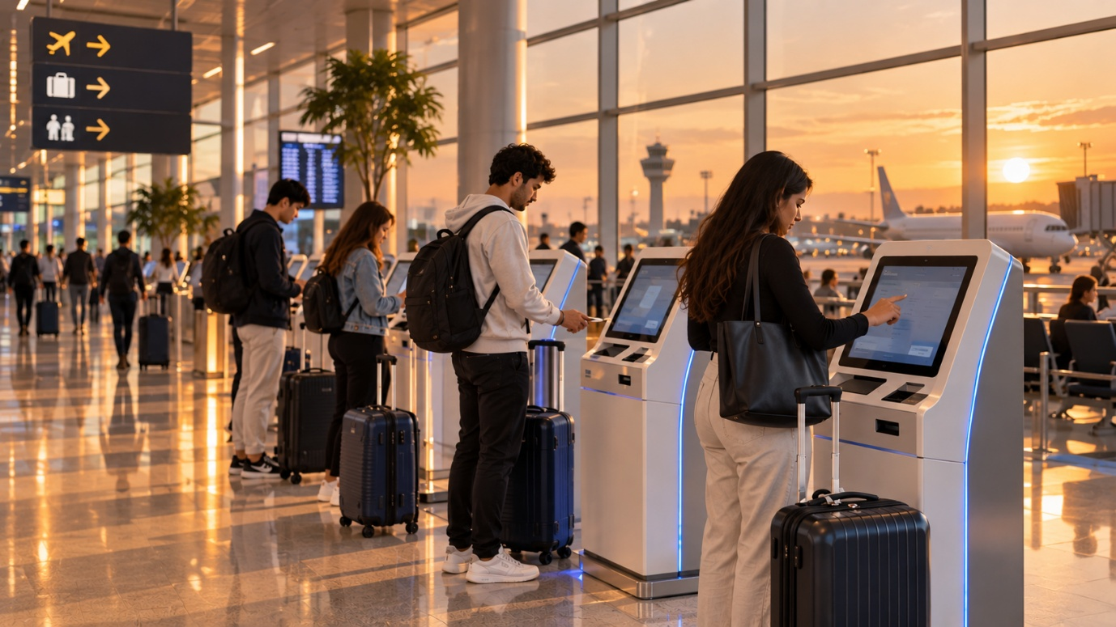

Version -3
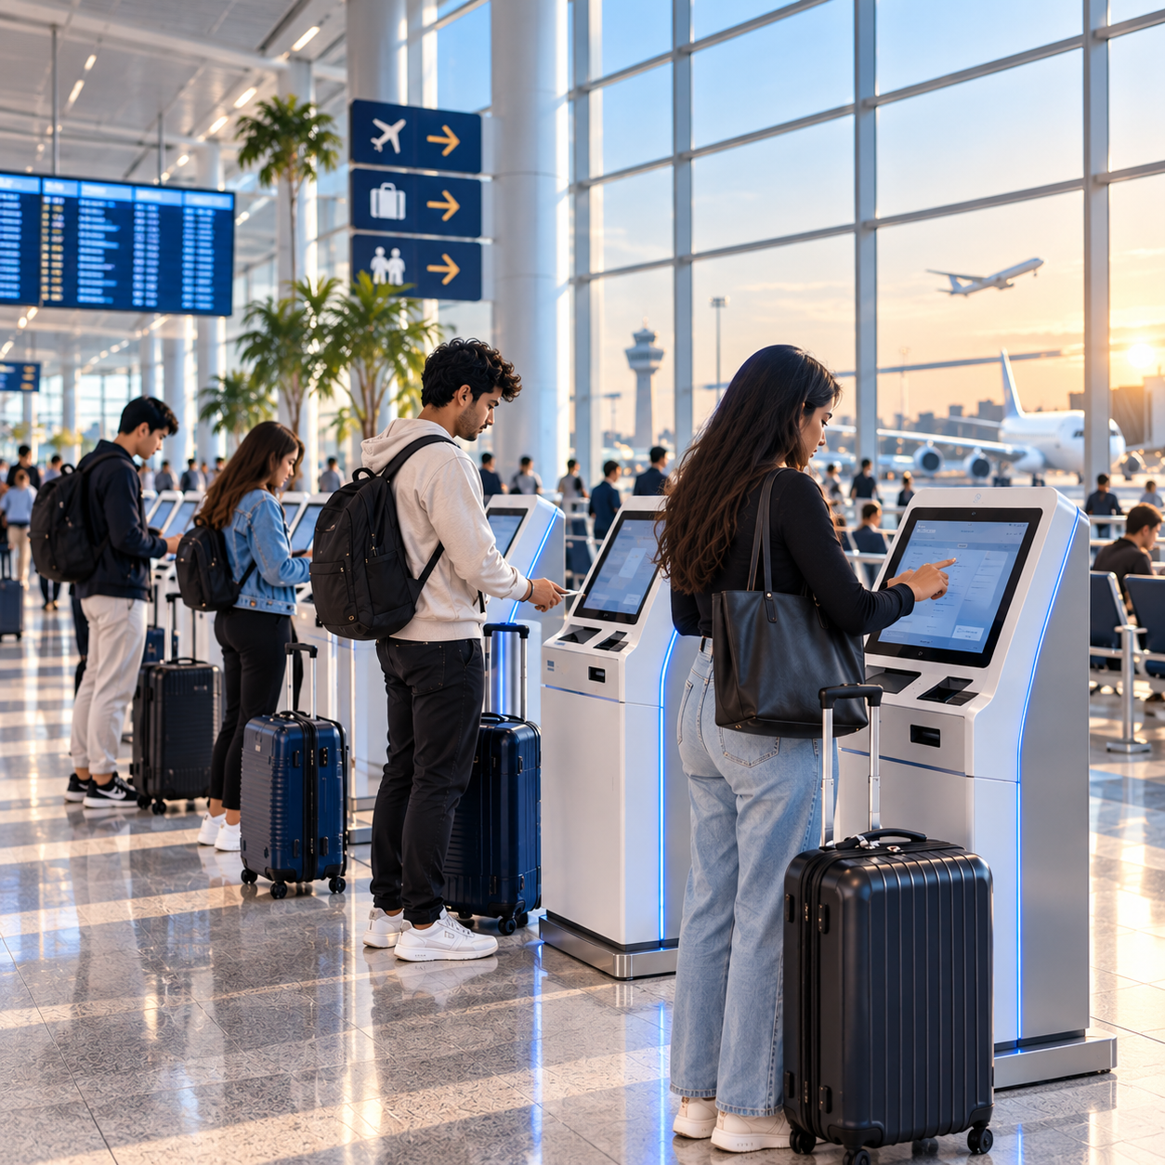

Version -4
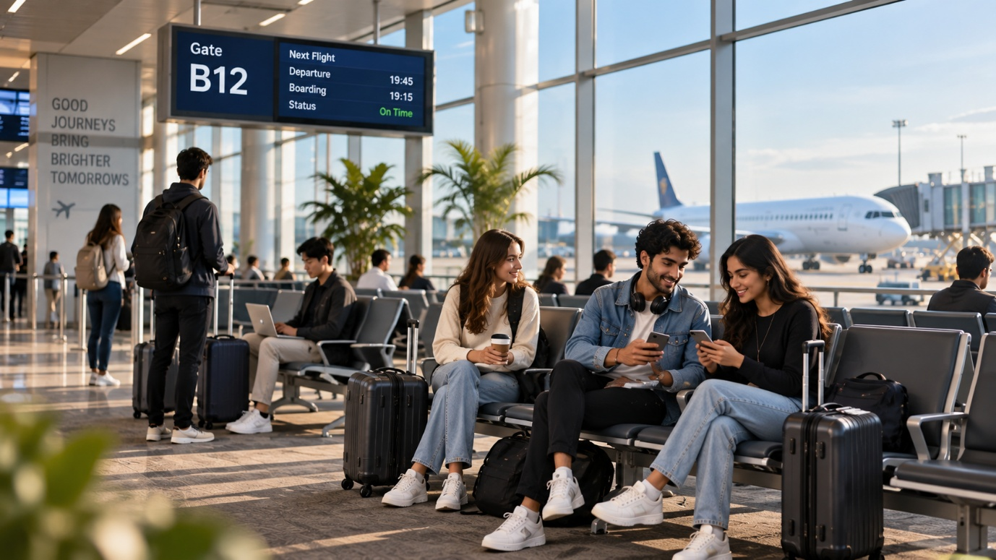
Refinement Table
Version | Variable Changed | Expected Effect | Actual Effect | Unexpected Changes
Original | None | Establish a baseline photorealistic airport self-service check-in image in 16:9 format with bright natural daylight. | Produced a realistic, spacious airport terminal with diverse young travellers using self-service kiosks, luggage, and aircraft visible in the background. | Some small screen/signage details appeared readable or semi-readable despite the text restrictions.
Version 1 | Style | Replace photorealism with a clean flat-vector illustration while keeping the subject, environment, lighting and composition broadly similar. | The image changed to a clean illustrated/vector appearance with simplified people, kiosks and airport architecture. | The illustration introduced more stylized colours, simplified facial features and additional graphic-style airport signage.
Version 2 | Lighting | Replace bright natural daylight with warm evening lighting while maintaining the photorealistic airport check-in scene. | The terminal became warmer and more cinematic, with sunset light, orange tones and stronger reflections on the floor. | The overall mood changed significantly, and the background became more sunset-focused than the original.
Version 3 | Aspect ratio | Change the composition from 16:9 landscape to a 1:1 square format suitable for social media. | The scene was reframed into a square composition while retaining the airport, travellers, kiosks and photorealistic style. | Some elements were repositioned or cropped, and the generated image also retained warm-looking light despite the original daylight instruction.
Version 4 | Environment | Replace the self-service check-in area with a boarding-gate waiting area while retaining the other major visual instructions. | The scene changed to a boarding-gate lounge with passengers sitting and waiting, carry-on luggage, gate seating and an aircraft near a jet bridge. | The AI introduced specific gate information such as “Gate B12,” “19:45,” “19:15” and “On Time,” plus promotional-style wall text, even though readable text was originally restricted.

Key Observation
The iterative process shows that changing one variable at a time makes it easier to observe the effect of each prompt modification. However, the results also demonstrate prompt bleed: changing one instruction does not guarantee that every other visual element will remain identical. The most noticeable example is Version 4, where changing the environment caused the model to introduce specific gate numbers, flight times and other text that were not requested.
Conclusion: Controlled single-variable refinement improves prompt testing, but every generated image still requires human inspection for unwanted text, inaccurate aviation details, visual consistency and professionalism.

Below is the completed continuation of Day 10 Lab 10 from Step 7 onward, based on the actual images generated in Versions 1–4. I have kept the lab’s terminology and structure, and I have specifically identified the prompt-bleed issues visible in your generated results.

Step 7 — Understand Prompt Bleed
Prompt bleed occurs when an instruction unintentionally affects other parts of the image or when elements from one instruction appear in an unwanted location.
Prompt-Bleed Analysis
Prompt Instruction | Intended Result | Unwanted Result | Corrective Instruction
Neutral blue-and-white colour palette | Consistent blue-and-white airport visual | Some versions introduced warmer colours, especially after lighting changes | “Maintain a neutral blue-and-white palette and avoid introducing additional dominant colours.”
No readable promotional text | Clean image without artificial text | Version 4 introduced readable gate information and wall text such as “Gate B12,” flight times and “On Time” | “Remove all readable text, flight numbers, gate numbers and promotional messages. Keep all displays blank.”
Realistic aviation environment | Realistic airport equipment and operations | Some screens contained artificial or unclear interface details | “Use realistic airport equipment but keep all digital screens blank or non-readable.”
Boarding-gate waiting area | Passengers waiting comfortably at an airport gate | The model added specific operational information and signage | “Show a generic boarding-gate waiting area without real or invented operational information.”

Step 8 — Correct Unwanted Elements
The following correction prompt can be used for the Version 4 image:
Remove all readable gate numbers, flight times, flight-status information, promotional messages and other artificial text. Keep the boarding-gate waiting area, passengers, luggage, aircraft and airport architecture unchanged. Keep the aircraft only outside the terminal windows. Maintain realistic passenger spacing and unobstructed walkways. Do not add airline logos, airport names, personal information or operational information. Keep digital displays blank or non-readable.
This follows the lab's recommended targeted-editing approach, including removing logos/text, keeping aircraft appropriately positioned and maintaining clear walkways.

Step 9 — Aviation Accuracy Audit
Accuracy Check | Acceptable? | Problem Identified | Required Correction
Aircraft structure appears realistic | Yes, mostly | Aircraft is generally recognizable and realistic | Minor visual inspection still required
Aircraft is located appropriately | Yes | Aircraft is shown outside the terminal through the windows | Keep aircraft outside the terminal
Passenger behaviour appears realistic | Yes | Passengers are seated, waiting and using normal travel equipment | No major correction required
Airport equipment appears usable | Yes, mostly | Kiosks and airport seating appear plausible | Review equipment details before publication
Walkways and exits are unobstructed | Yes | Main passenger movement areas remain reasonably clear | Maintain clear walkways
Signs are accurate or intentionally blank | No | Version 4 introduced invented gate and flight information | Remove readable operational information
Uniforms do not misuse real branding | Yes | No obvious real airline uniform branding is required | Continue avoiding airline branding
No personal information is visible | Yes | No obvious passenger personal information is visible | Keep screens and documents non-readable
No unsafe activity is shown | Yes | Passengers are behaving normally | No major correction required
No misleading operational information appears | No | Version 4 displayed invented gate/flight information | Remove all fake operational details
The lab specifically requires checking aircraft placement, passenger behaviour, equipment, walkways, signs, branding, personal information and misleading operational information.

Step 10 — Professionalism Audit
Professionalism Criterion | Score from 1–5 | Comments
Visual quality | 5/5 | High-quality and visually detailed airport environment
Business relevance | 5/5 | Directly relevant to aviation, passenger experience and airport technology
Composition | 5/5 | Clear foreground subject and supporting airport environment
Colour consistency | 4/5 | Generally consistent, although lighting changes affected the colour balance
Readability | 3/5 | Artificial text and airport displays create some concerns
Audience suitability | 5/5 | Suitable for a BBA Aviation Management presentation after correction
Brand neutrality | 5/5 | No intentional real airline branding
Overall professionalism | 4/5 | Strong visual quality, but human review and text correction are required
Overall observation: The image has strong presentation value, but it should not be treated as an authentic operational airport photograph because AI-generated text and operational details can be inaccurate.

Step 11 — Three Aviation Visuals
The lab requires three aviation visuals covering airline marketing, airport awareness and an aviation presentation.
Visual A — Airline Marketing
Business Purpose
Create an attractive campaign visual encouraging students to explore domestic destinations.
Target Audience
Young adults and university students interested in travel.
Five-Part Prompt
Subject: Young adult travellers preparing for a domestic journey
Style: Professional photorealistic commercial photography
Environment: Modern Indian airport terminal with domestic-travel atmosphere
Lighting: Bright natural daylight
Aspect ratio: 16:9 landscape
Complete Prompt
Create a professional photorealistic image of diverse young adult travellers preparing for a domestic journey inside a modern airport terminal. Show travel bags, a clean check-in environment and an energetic but realistic passenger atmosphere. Use bright natural daylight and a professional blue-and-white colour palette. Use a 16:9 landscape composition suitable for an aviation marketing presentation. Do not include real airline logos, airline names, ticket prices, discount claims, airport names, personal information or readable promotional text.
Problems to Check
- Unwanted airline logos
- Fake ticket prices
- Unreadable or incorrect promotional text
- Unrealistic aircraft or airport details
Revised Prompt
Keep the same scene but remove all logos, airline names, prices and promotional text. Keep the visual generic and brand-neutral.

Visual B — Airport Awareness
Business Purpose
Encourage passengers to keep airport terminal walkways clear.
Target Audience
Airport passengers and travellers.
Five-Part Prompt
Subject: Passengers maintaining clear terminal walkways
Style: Clean professional photorealistic photography
Environment: Modern airport terminal concourse
Lighting: Bright neutral lighting
Aspect ratio: 16:9 landscape
Complete Prompt
Create a professional photorealistic image of passengers moving responsibly through a modern airport terminal while keeping the main walkways clear. Show travellers standing to the side with their luggage rather than blocking passenger movement. Include realistic airport seating and terminal infrastructure. Use bright neutral lighting and a clean blue-and-white colour palette. Use a 16:9 landscape format. Do not include airline logos, airport names, personal information or inaccurate safety signage.
Problems to Check
- Bags blocking walkways
- Crowded or unsafe passenger movement
- Incorrect emergency-exit signs
- Unnecessary text
Revised Prompt
Maintain realistic passenger spacing, keep all walkways and emergency exits unobstructed, remove inaccurate signage and keep all displays blank.

Visual C — Aviation Presentation
Presentation Title
Improving Passenger Experience Through Airport Technology
Business Purpose
Provide a professional presentation visual explaining the role of airport self-service technology.
Target Audience
Students, teachers and aviation-management audiences.
Five-Part Prompt
Subject: Passengers using airport self-service technology
Style: Professional photorealistic corporate photography
Environment: Modern international airport terminal
Lighting: Bright natural daylight
Aspect ratio: 16:9 landscape
Complete Prompt
Create a professional photorealistic presentation image showing diverse young adult travellers using realistic self-service check-in technology inside a modern international airport terminal. Show clean kiosks, realistic luggage, clear passenger movement and a spacious terminal environment. Use bright natural daylight and a neutral blue-and-white colour palette. Use a 16:9 landscape composition suitable for a professional business presentation. Do not include airline logos, airport names, passenger data, boarding-pass details, fake charts, statistics or readable promotional text.
Problems to Check
- Fake statistics
- Fake charts
- Unreadable text
- Incorrect kiosk design
- Personal information
- Airline branding
Revised Prompt
Remove all charts, statistics, logos and readable text. Keep the technology realistic and leave all digital screens blank or non-readable.

Step 12 — Image-Generation Limitations
Question | Answer
1. Did the tool create readable text? | Yes. Some generated airport signs contained readable or semi-readable text, particularly Version 4.
2. Were hands and faces realistic? | Mostly yes. The people were generally realistic, although AI-generated human details should still be inspected closely.
3. Were aircraft and airport structures realistic? | Mostly yes. The airport environment and aircraft were visually convincing, but operational accuracy cannot be assumed from appearance alone.
4. Did the image contain unwanted logos? | No obvious real airline logo was intentionally included, but this should always be checked.
5. Did it introduce cultural or demographic stereotypes? | No obvious stereotype was identified in the generated versions reviewed.
6. Did it follow the requested aspect ratio? | Yes. Version 3 was changed to a square 1:1 format as requested.
7. Did it include elements that were not requested? | Yes. Version 4 introduced gate numbers, flight times, status information and wall text.
8. Could the image mislead viewers? | Yes. Fake operational information could make viewers believe that the image represents a real airport or flight.
9. Should any AI-use disclosure be added? | Yes, when required by the context, institution or platform.
10. What human corrections would be required? | Remove fake text, verify aviation details, check aircraft placement, inspect people/equipment and confirm that no branding or personal information is present.
These limitations directly correspond to the lab's required questions about text, people, aviation structures, logos, stereotypes, aspect ratio, unwanted elements, misleading content, disclosure and human correction.

Step 13 — Ethical and Responsible-Use Check
Check | Response
Is the image deceptive? | It could become deceptive if presented as an authentic photograph of a real airport or event.
Does it imitate a real airline or airport without permission? | The prompts were designed to avoid real airline and airport branding.
Does it include unauthorised logos? | No intentional real logos were requested; final images should still be checked.
Does it misrepresent a real event? | It could if the generated scene were presented as documentation of an actual event.
Does it depict a real individual without consent? | The images use AI-generated people rather than intentionally depicting a named real individual.
Does it reinforce stereotypes? | No obvious stereotype was identified in the reviewed images.
Does it contain false safety information? | Version 4 contained invented operational information, so it requires correction.
Could viewers mistake it for an authentic operational photograph? | Yes, particularly because the photorealistic versions look like real airport photography.
Are usage rights understood? | The intended use and applicable tool/platform terms should be checked before commercial publication.
Is AI-use disclosure required? | Disclosure should be made when required by the institution, platform or applicable rules.
The lab specifically asks students to assess deception, branding, real events/individuals, stereotypes, safety information, authenticity, usage rights and disclosure.

Step 14 — Peer Review
Since an actual classmate's review has not been provided, the following is a self-review based on the generated Version 4 image. It should be replaced with actual peer feedback if your instructor requires evidence of peer review.
Review Question | Yes/No | Suggested Improvement
Is the subject clear? | Yes | Keep passengers and airport environment clearly visible.
Is the style appropriate? | Yes | Photorealistic style is suitable for a professional aviation presentation.
Is the environment realistic? | Yes, mostly | Verify airport equipment and aircraft details.
Is the lighting suitable? | Yes | Maintain consistent natural lighting where required.
Is the aspect ratio appropriate? | Yes | Select the ratio according to the intended use.
Are there unwanted elements? | Yes | Remove invented gate, flight and promotional text.
Are there aviation inaccuracies? | Potentially | Conduct a detailed operational review before publication.
Is the image professional? | Yes, after correction | Remove artificial text and misleading information.
Is the image ethical and responsible? | Yes, after correction | Do not present it as an authentic operational photograph.
Is further human review required? | Yes | Human review is necessary before final publication.
The lab requires peer review followed by revision of the visual.

Step 15 — Student Reflection
1. What are the five parts of an effective image prompt?
The five parts are subject, medium or style, environment, lighting and aspect ratio. These components provide the image-generation tool with clearer instructions about what to create and how the final image should look.
2. What is the difference between image generation and image retrieval?
Image retrieval finds an existing image from a source, while image generation creates a new image based on a text prompt.
3. Why should only one variable be changed at a time?
Changing one variable at a time makes it easier to identify which instruction caused a particular visual change. It also makes the refinement process more controlled.
4. What is prompt bleed?
Prompt bleed occurs when an instruction unintentionally affects another part of the generated image or causes an unwanted element to appear.
5. Give one example of an aviation inaccuracy found in an AI-generated image.
One example from the refinement process was the introduction of invented gate and flight information, such as “Gate B12,” a departure time and an “On Time” status, even though no operational information was requested.
6. Why should text normally be added separately in a design tool?
AI image-generation tools can produce distorted, incorrect or meaningless text. Adding text separately in a tool such as Canva provides better control over spelling, formatting and accuracy.
7. Why should real airline logos be avoided?
Real airline logos can create brand, trademark and authenticity concerns. A generic aviation visual is safer when a real brand is not required.
8. How did peer feedback improve your image?
Peer review can identify visual problems that the creator may overlook, such as fake text, unrealistic airport details, poor composition or misleading information. The feedback can then be used to refine the image.
9. What ethical concerns apply to AI-generated aviation visuals?
Important concerns include misleading viewers, fake operational information, unauthorised branding, privacy, stereotypes, inaccurate safety information, authenticity and appropriate AI disclosure.
10. Why must an AI-generated image be reviewed before publication?
AI-generated images can contain realistic-looking but incorrect people, equipment, aircraft, signs, text or operational details. Human review helps identify and correct these problems before the image is used publicly.

Step 16 — GitHub File Structure
Your GitHub folder should follow this structure:
genai-business-portfolio/
└── day-10-image-generation/
├── aviation-image-generation.md
└── images/
├── weak-prompt.png
├── structured-prompt.png
├── version-1-style.png
├── version-2-lighting.png
├── version-3-aspect-ratio.png
├── version-4-environment.png
├── corrected-image.png
├── visual-a-airline-marketing.png
├── visual-b-airport-awareness.png
└── visual-c-aviation-presentation.png
The lab specifies the Markdown filename aviation-image-generation.md, an images folder, and the required sections for the activity.
AI Usage Declaration
An AI image-generation tool was used to create the visuals in this activity. I independently designed and refined the prompts, checked the images for accuracy, professionalism, bias and responsible use, and completed the reflection.

Step 17 — GitHub Upload
Repository:
genai-business-portfolio
Folder:
day-10-image-generation
Upload:
aviation-image-generation.md
Images:
day-10-image-generation/images/
Commit message:
Add Day 10 Lab 10 - Aviation Image Generation
The lab specifically requires uploading the Markdown file and generated images and using this commit message.

Final Assessment Checklist
Assessment Criterion | Status
Applied all five image-prompt components | Yes
Changed one variable at a time | Yes
Identified prompt bleed | Yes
Corrected unwanted elements | Yes — correction prompt prepared
Checked aviation accuracy | Yes
Evaluated professionalism | Yes
Avoided unauthorised logos and personal data | Yes
Completed the ethical-use check | Yes
Revised the image after peer review | Pending actual peer feedback
Uploaded the activity and images to GitHub | Pending upload
The final submission requirements include the weak and structured images, four refinements, prompt-bleed analysis, corrected visual, accuracy and professionalism audits, three aviation visuals, ethical-use check, peer-review evidence, reflection, and GitHub links.
Important: For your actual submission, do not claim that peer review or GitHub upload is complete until you have actually done those two activities.

